EX.NO. 3A: ECHO CLIENT AND ECHO SERVER APPLICATIONS USING TCP SOCKETS

AIM:
To write a socket program to implement echo client and echo server applications using TCP
sockets in java.

ALGORITHM:
ECHO SERVER:
Step 1: Start the program.
Step 2: Import necessary packages to access the predefined classes and its methods.
Step 3: Create server side socket using ServerSocket class.
Step 4: Accept connection from client by using accept() method.
Step 5: Initialize object for DataInputStream class with getInputStream() method of Socket class to
receive message from client.
Step 6: Initialize object for DataOutputStream class with getOutputStream() method of Socket class
to send message to client.
Step 7: Using readUTF() method receive message from client.
Step 8: Using writeUTF() method to echo received message to client.
Step 8: Stop the program.

ECHO CLIENT:
Step 1: Start the program.
Step 2: Import necessary packages to access the predefined classes and its methods.
Step 3: Create client side socket using Socket class.
Step 4: Initialize object for DataInputStream class with getInputStream() method of Socket class to
receive message from client.
Step 5: Initialize object for DataOutputStream class with getOutputStream() method of Socket class
to send message to client.
Step 6: Using readUTF() and writeUTF() method send and receive mesaage from server.
Step 7: Stop the program.

PROGRAM :
ChatClient.java
import java.io.*;
import java.net.*;
import java.util.*;

public class ChatClient {

public static void main(String[] args) {

try {
Socket s = new Socket("localhost", 6666);
System.out.println("Connected to server.");

DataInputStream din = new DataInputStream(s.getInputStream());
DataOutputStream dout = new DataOutputStream(s.getOutputStream());

Scanner input = new Scanner(System.in);

String sendData = "";
String receiveData = "";
while (!sendData.equalsIgnoreCase("stop")) {

System.out.print("TO SERVER: ");
sendData = input.nextLine();

dout.writeUTF(sendData);
dout.flush();

if (sendData.equalsIgnoreCase("stop")) {
break;
}

receiveData = din.readUTF();
System.out.println("SERVER SAYS: " + receiveData);
}

din.close();
dout.close();
input.close();
s.close();

} catch (Exception e) {
System.out.println("Error: " + e.getMessage());
}
}
}

ChatServer.java
import java.io.*;
import java.net.*;
import java.util.*;

public class ChatServer {

public static void main(String[] args) {

try {
ServerSocket ss = new ServerSocket(6666);
System.out.println("Server started. Waiting for client...");

Socket s = ss.accept();
System.out.println("Client connected.");

DataInputStream din = new DataInputStream(s.getInputStream());
DataOutputStream dout = new DataOutputStream(s.getOutputStream());

Scanner input = new Scanner(System.in);

String sendData = "";
String receiveData = "";

while (!receiveData.equalsIgnoreCase("stop")) {

receiveData = din.readUTF();
System.out.println("CLIENT SAYS: " + receiveData);

if (receiveData.equalsIgnoreCase("stop")) {
break;
}

System.out.print("TO CLIENT: ");
sendData = input.nextLine();

dout.writeUTF(sendData);
dout.flush();
}

din.close();
dout.close();
input.close();
s.close();
ss.close();

} catch (Exception e) {
System.out.println("Error: " + e.getMessage());
}
}
}

EXECUTION:
Step 1: Save Echo Server java file as ChatServer.java and ChatClient java file as EchoClient.java.
Step 2: Open two cmd prompt for client and server.
Step 3: Set path for javac compiler and java interpreter in cmd prompt as follows set path=” C:\Program Files\Java\jdk1.7.0_79\bin”;
Step 4: Compile your server java program as follows javac ChatServer.java It generates Bytecode file (or Object file) as ChatServer.class
Step 5: Compile your client java program as follows javac ChatClient.java It generates Bytecode file (or Object file) as ChatClient.class
Step 6: Execute your server java program as follows java ChatServer
Step 7: Execute your client java program as follows java ChatClient

OUTPUT:
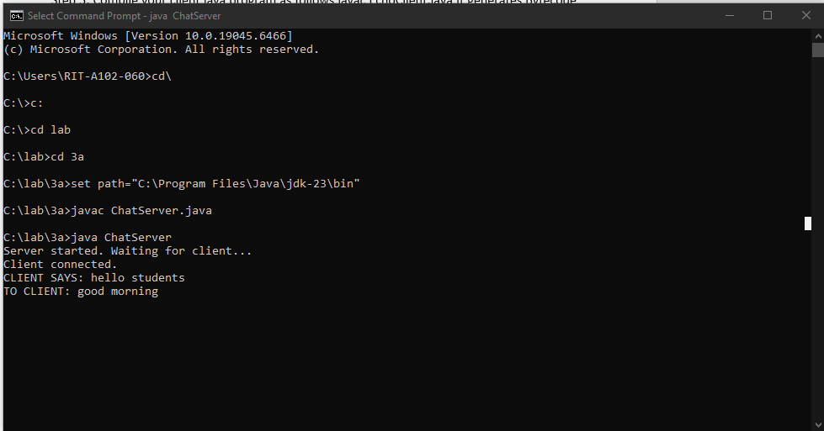

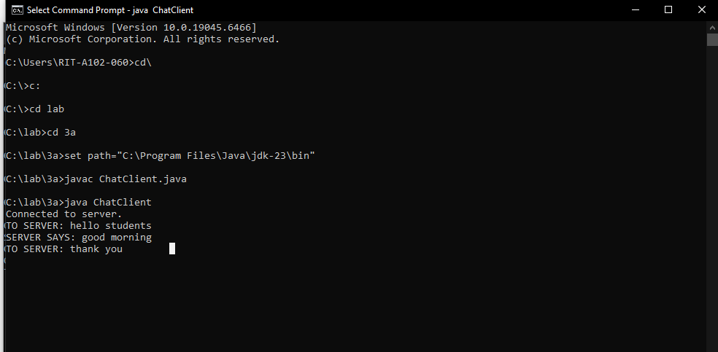

RESULT:
Thus the socket program to implement echo client and echo server applications using TCP sockets in java has been executed successfully and output got verified.

EX.NO. 3B: CHAT APPLICATION USING TCP SOCKETS
AIM:
To write a socket program to implement chat application using TCP sockets in java.
ALGORITHM:
CHAT SERVER:
Step 1: Start the program.
Step 2: Import necessary packages to access the predefined classes and its methods.
Step 3: Create server side socket using ServerSocket class.
Step 4: Accept connection from client by using accept() method.
Step 5: Initialize object for DataInputStream class with getInputStream() method of Socket class to receive message from client.
Step 6: Initialize object for DataOutputStream class with getOutputStream() method of Socket class to send message to client.
Step 7: Using readUTF() and writeUTF() method send and receive mesaage between client and server.
Step 8: Stop the program.
CHAT CLIENT:
Step 1: Start the program.
Step 2: Import necessary packages to access the predefined classes and its methods.
Step 3: Create client side socket using Socket class.
Step 4: Initialize object for DataInputStream class with getInputStream() method of Socket class to receive message from client.
Step 5: Initialize object for DataOutputStream class with getOutputStream() method of Socket class to send message to client.
Step 6: Using readUTF() and writeUTF() method send and receive mesaage between client and server.
Step 7: Stop the program.

PROGRAM :
ChatClient.java
import java.io.*;
import java.net.*;
import java.util.*;

public class ChatClient {
public static void main(String[] args) {
try {
Socket socket = new Socket("localhost", 6666);

DataInputStream din =
new DataInputStream(socket.getInputStream());

DataOutputStream dout =
new DataOutputStream(socket.getOutputStream());

Scanner input = new Scanner(System.in);

String sendData = "";
String receiveData = "";

while (!sendData.equalsIgnoreCase("stop")) {
System.out.print("TO SERVER: ");
sendData = input.nextLine();

dout.writeUTF(sendData);
dout.flush();

if (sendData.equalsIgnoreCase("stop")) {
break;
}

receiveData = din.readUTF();
System.out.println("SERVER SAYS: " + receiveData);
}

input.close();
din.close();
dout.close();
socket.close();

} catch (Exception e) {
System.out.println("Error: " + e.getMessage());
}
}
}

ChatServer.java
import java.io.*;
import java.net.*;
import java.util.*;

public class ChatServer {
public static void main(String[] args) {
try {
ServerSocket serverSocket = new ServerSocket(6666);

System.out.println("Server started...");
Socket socket = serverSocket.accept();
System.out.println("Client connected.");

DataInputStream din =
new DataInputStream(socket.getInputStream());

DataOutputStream dout =
new DataOutputStream(socket.getOutputStream());

Scanner input = new Scanner(System.in);

String sendData = "";
String receiveData = "";

while (!receiveData.equalsIgnoreCase("stop")) {

receiveData = din.readUTF();
System.out.println("CLIENT SAYS: " + receiveData);

if (receiveData.equalsIgnoreCase("stop")) {
break;
}

System.out.print("TO CLIENT: ");
sendData = input.nextLine();

dout.writeUTF(sendData);
dout.flush();

if (sendData.equalsIgnoreCase("stop")) {
break;
}
}

input.close();
din.close();
dout.close();
socket.close();
serverSocket.close();

System.out.println("Connection closed.");

} catch (Exception e) {
System.out.println("Error: " + e.getMessage());
}
}
}

EXECUTION:
Step 1: Save Chat Server java file as ChatServer.java and Chat Client java file as ChatClient.java.
Step 2: Open two cmd prompt for client and server.
Step 3: Set path for javac compiler and java interpreter in cmd prompt as follows set path=” C:\Program Files\Java\jdk1.7.0_79\bin”;
Step 4: Compile your server java program as follows javac ChatServer.java It generates Bytecode file (or Object file) as ChatServer.class
Step 5: Compile your client java program as follows javac ChatClient.java It generates Bytecode file (or Object file) as ChatClient.class
Step 6: Execute your server java program as follows java ChatServer
Step 7: Execute your client java program as follows java ChatClient

OUTPUT :
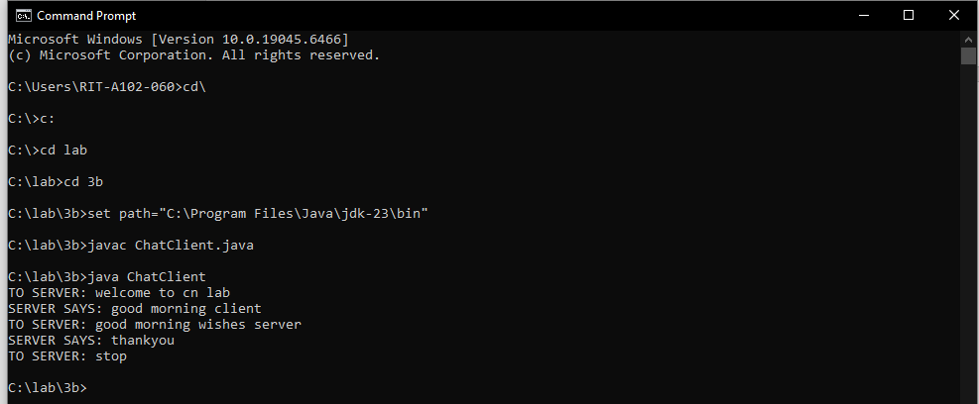
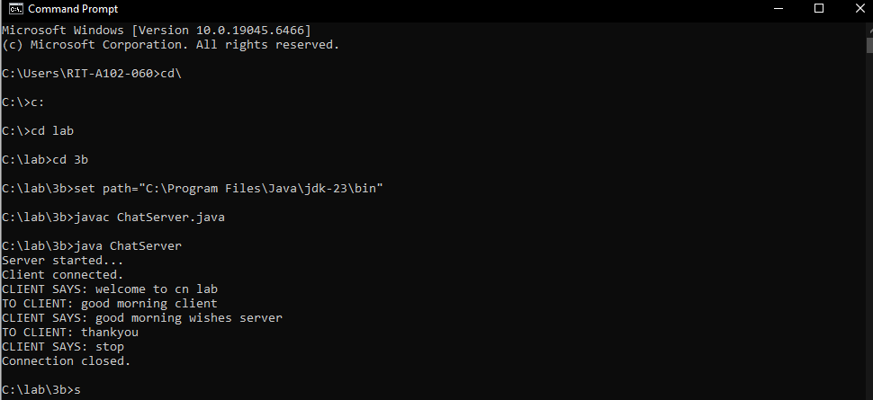
RESULT: Thus the socket program to implement chat application using TCP sockets in java has been executed successfully and output got verified.

